
Assignment 1

Submitted By
Student ID: | Student Name:
252602038 | Ahmed Refaat Mousa

Submitted to: Dr. Safwat Elsharkawi

Introduction about your current Managerial Role
My Role: Department lead for Infotainment/Entertainment systems in a premium automotive company
Since 2022, the automotive and software market has become significantly more competitive—especially with Chinese automakers entering with many variants and options that address almost every market segment. This has raised profitability pressure per segment because high-quality features are becoming accessible across all tiers. In parallel, model launches can no longer slip as they did in the past; time-to-market must be faster to keep up with rapidly emerging technologies. As department lead, it became necessary to build a clear business plan that strengthens competitiveness, accelerates feature readiness, and improves execution quality across teams.
Responsibilities: lead the Infotainment/Entertainment department and prepare a business plan that achieves:
- Identify competitor strengths; build team awareness
- Define and prioritize features to protect/grow market position
- Spot risks early; execute mitigations
- Standardize best practices across teams
- Increase customer awareness and perceived value of our system

Goals

Goal 1 — Competitor Benchmarking & Team Awareness
Field | Content
Goal | Benchmark Chinese automakers’ Infotainment/Entertainment strengths and build team awareness
Time-Frame | M0–M6 initial; refresh quarterly
Targets | - Identify China top-10 best-sellers (mid + premium)  - Deep-dive competitor features (Infotainment/Entertainment)  - Run expert + dev exposure sessions (static + driving)
Measurements (KPIs) | - Top-10 list validated for next 6 months  - 20–40 key features documented and validated (expert + marketing)  - Evidence captured (forums/social complaints)  - Awareness: ≥10 hrs/person exposure (≈5 hrs review + 5 hrs driving)  - Distribute screens across Team areas that shows competitor features
Success Criteria | - Teams can explain competitor feature set and gaps  - List of requirements per features  - List Required resources per feature

Goal 2 — China Feature Roadmap (Define, Prioritize, Plan)
Field | Content
Goal | Define and prioritize the China feature roadmap and delivery timeline
Time-Frame | M3–M6 plan; M6–M18 execute
Targets | - Split backlog:  (a) enhance existing features  (b) build new competitor-only features  - Prioritize by market need and feasibility  - Publish release plan (resources + deadlines)
Measurements (KPIs) | - Prioritized backlog approved  - Release plan published (owners/resources/dates)  - ≥10 new features planned for delivery within 18 months  - Demo readiness before release (e.g., demo by month 7 if dev=10 months)
Success Criteria | - Roadmap is approved, resourced, and tracked against milestones  - adaptive correction in quarterly basis to ensure deadline.

Goal 3 — Best Practices Standardization (SOP)
Field | Content
Goal | Standardize best practices across teams using SOPs (Standard Operating Procedures)
Time-Frame | M0–M6 define; M6–M18 enforce
Targets | - Capture lessons learned from old projects  - Define SOP per major feature (dev + test + release)  - Share and train across teams
Measurements (KPIs) | - SOP coverage (% key features with SOP)  - Adoption rate (teams using SOP in reviews/plans)  - Stability improvement of unstable features ~65% within first half of timeline  - Test automation +70% vs previous generation
Success Criteria | Consistent execution across teams; fewer repeated issues release-to-release ( < 15% per release)

Goal 4 — Customer Awareness & Perceived Value
Field | Content
Goal | Increase customer awareness and perceived value of our Infotainment/Entertainment system (China focus)
Time-Frame | M6–M18 (preparation M3–M6)
Targets | - Pre-series demos and influencer/target-user trials  - Marketing enablement (feature messaging + demos)  - Collect structured user feedback
Measurements (KPIs) | - Pre-series vehicles distributed to testers/influencers  - Satisfaction ≥80% for new features (pilot/beta)  - Awareness indicators: campaign reach/engagement, demo attendance, product page views
Success Criteria | Measurable awareness uplift and improved sentiment/feedback (rating > 3-stars for new features and >= 4-stars for old)

Strategies
- China-first competitive benchmarking + rapid roadmap
  - continuously benchmark top Chinese players
  - translate gaps into a prioritized backlog with committed release milestones.
- Standardize execution via SOP + governance
  - unify best practices across teams (definition of done, reviews, testing, release gates) to improve quality and predictability.
- Closed-loop validation with early risk control
  - Run early pilots/demos with target users/influencers
  - Track KPIs
  - Manage a risk register
  - Adjust priorities based on feedback and measured outcomes.

Plans
Plan Items |  | Sub-Items
Confirm scope and success metrics (M0–M1) | - Confirm China scope (mid + premium segments) and the definition of “top-10” best sellers  - Lock KPIs per goal and reporting cadence (weekly operational, monthly management)
Build competitor benchmark baseline (M0–M3) | - Collect market data and identify top-10 Chinese best-sellers  - Purchase/access vehicles and collect Infotainment/Entertainment feature evidence  - Create the competitor feature catalog (20–40 key features)
Run awareness & exposure program (M2–M6) | - Execute static + driving sessions for expert/dev teams  - Publish a concise “China competitor insights” brief and keep it updated quarterly
Translate gaps into a China roadmap (M3–M6) | - Split backlog: enhance existing vs build new competitor-only features  - Prioritize features (market impact, feasibility, dependency, cost)  - Create an 18-month release plan with owners, resources, and milestones
Execute delivery with built-in testing (M6–M18) | - Deliver features per milestones (implementation + unit/integration/acceptance testing)  - Produce working demos ahead of release for marketing/pilot readiness  - Collect market feedback and adjust priorities when needed
Establish SOP and quality governance (M0–M6 define; M6–M18 enforce) | - Capture lessons learned from old projects and identify “stable reference” features  - Create SOP templates + Definition of Done + release readiness gates  - Increase test automation and track stability improvement KPIs
Customer awareness and perceived value (M6–M18) | - Run pilots/betas with target users/influencers and measure satisfaction  - Prepare marketing enablement content (demos, feature messaging, comparisons)  - Use voice-of-customer insights to refine features and roadmap

Organizing

Organization Chart

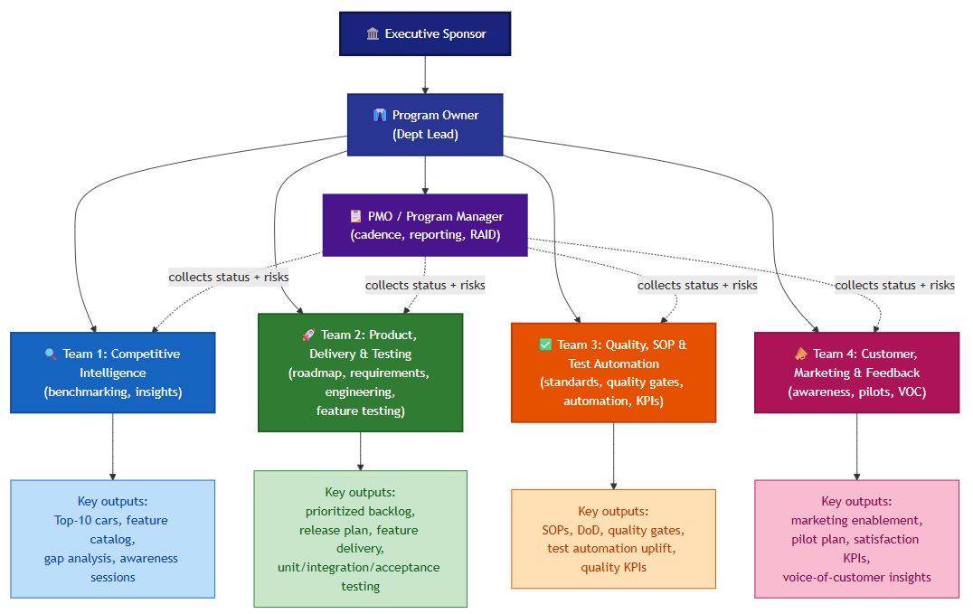
Figure 1- Org Chart

Work Breakdown & Ownership (What / Who / How)
What to Do ?
What | Details
Confirm scope and success metrics | - Confirm China scope (mid + premium segments) and definition of “top-10” best sellers  - Lock KPIs per goal and define reporting cadence
Set up program governance and working artifacts | - Create action log + RAID log (risks/issues/dependencies) + decision log  - Agree templates: benchmark report, feature catalog, SOP format, release readiness checklist
Benchmark competitors and build the evidence base | - Identify top-10 China best-sellers and collect data/evidence  - Build competitor feature catalog (20–40 key Infotainment/Entertainment features)  - Validate findings (expert + marketing) and keep baseline refreshed quarterly
Run team awareness and exposure activities | - Execute static + driving sessions and ensure required awareness hours/person  - Publish “competitor insights” brief and communicate it across teams
Convert insights into a China feature roadmap | - Split backlog: enhance existing features vs build new competitor-only features  - Prioritize features (market impact, feasibility, dependencies, cost)  - Define an 18-month release plan (owners, resources, milestones)
Deliver features with built-in testing | - Implement features and execute unit/integration/acceptance testing  - Produce working demos ahead of release for pilot/marketing readiness  - Track progress vs milestones and adjust plans when needed
Standardize best practices through SOP (Standing Plan) | - Capture lessons learned and define SOP per major feature (dev + test + release)  - Define Definition of Done and quality gates for releases  - Improve test automation and stability KPIs vs previous generation
Run closed-loop customer validation and awareness | - Execute pilots/betas with target users/influencers and measure satisfaction  - Prepare marketing enablement (feature messaging, demos, comparisons)  - Feed voice-of-customer insights ➡️ backlog/corrective actions
Who will Do What ?
Role |  | Responsibilities
Executive Sponsor |  | Approve budget, resolve escalations, sign off major scope changes
Program Owner (Dept Lead) |  | Set direction, approve roadmap priorities, chair steering reviews
PMO / Program Manager |  | Run cadence (weekly/monthly), maintain RAID log, consolidate status, track KPIs
Team 1 Lead — Competitive Intelligence |  | Own competitor benchmark, maintain feature catalog, run awareness sessions
Team 2 Lead — Product, Delivery & Testing |  | Own backlog, release plan, feature implementation, and feature-level testing
Team 3 Lead — Quality, SOP & Test Automation |  | Define SOPs, enforce quality gates, drive test automation uplift, track stability KPIs
Team 4 Lead — Customer, Marketing & Feedback |  | Run pilots/betas, prepare marketing content, collect and analyze VOC feedback

How will it be Done?
Workstream | Details
Workstream 1 - Benchmark & Align (M0-M6) | identify top competitors, build the feature catalog, validate findings, and align teams on the benchmark baseline.
Workstream 2 - Roadmap & Planning (M3-M6) | convert gaps into a prioritized backlog, assign owners, define milestones, and publish the 18-month release plan.
Workstream 3 - Delivery & Testing (M6-M18) | implement prioritized features, run unit/integration/acceptance testing, and prepare demos before release.
Workstream 4 - Standardize & Control (M0-M18) | define and apply SOPs, Definition of Done, release readiness gates, and automation KPIs across all teams.
Workstream 5 - Customer Validation & Feedback (M6-M18) | run pilots/betas, collect customer and market feedback, and feed insights into backlog updates and corrective actions.
Execution Governance
Coordination model | Weekly team sync, monthly management review, and quarterly strategy/checkpoint review
Tracking tools | Feature backlog, release roadmap, KPI dashboard, and RAID log
Decision method | Strategic priorities stay centralized with Program Owner; execution details stay decentralized within each team
Control mechanism | PMO consolidates status, risks, and actions; Quality team checks compliance to SOP and quality gates

Plan Timeline
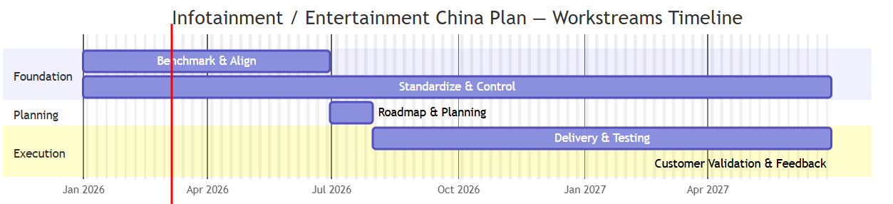
Figure 2- Plan Timeline

Centralized vs Decentralized
Decision Area | Cen / Decen | Owner | Why
Program goals, KPIs, and China scope | Centralized | Executive Sponsor + Program Owner | Ensure one clear direction and shared success criteria
Competitor benchmark baseline and top-10 target vehicles | Centralized | Program Owner + Team 1 Lead | Keep comparison logic consistent across teams
Feature priorities and release milestones | Centralized | Program Owner | Avoid conflicting priorities and protect strategic focus
Budget, major staffing changes, and scope trade-offs | Centralized | Executive Sponsor + Program Owner | These decisions affect the full program and require leadership approval
SOP standards, quality gates, and KPI definitions | Centralized | Team 3 Lead + Program Owner | Standardization is needed to ensure quality consistency
Risk acceptance, major escalations, and go/no-go decisions | Centralized | Program Owner + PMO + Sponsor | High-impact decisions need cross-program visibility and control
Market analysis execution and evidence collection | Decentralized | Team 1 | The team has the right expertise and can work faster operationally
Feature design, implementation approach, and sprint planning | Decentralized | Team 2 | Technical teams should choose the best delivery method within agreed priorities
Test execution details and automation implementation | Decentralized | Team 2 + Team 3 | Teams need flexibility to adapt testing to feature and platform needs
Pilot execution, campaign content, and customer feedback collection | Decentralized | Team 4 | Customer-facing activities must adapt quickly to target users and market feedback
Day-to-day issue resolution and task planning | Decentralized | Each Team Lead | Faster local decisions improve execution speed

Recommended model: a hybrid structure — centralize strategic, budget, quality, and release decisions; decentralize technical execution, analysis activities, testing details, and customer-facing operations. This keeps the program aligned while preserving team agility.

